Created a VPC with CIDR:10.1.0.0/18

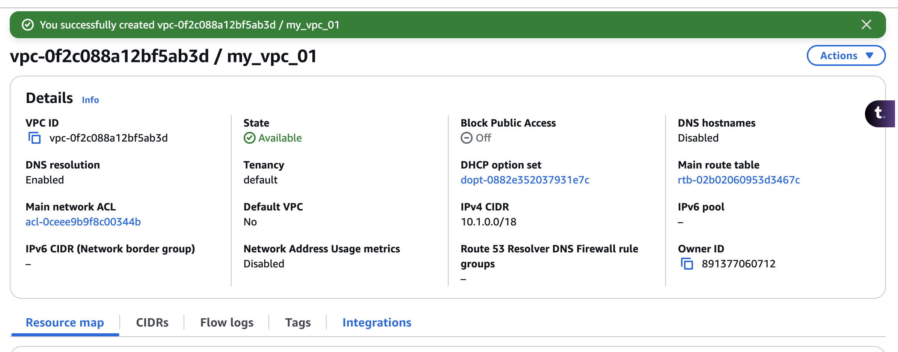

Enabled DNS Support and Hostnames

**Subnet Setup:**

**Public Subnets:**

1 in us-east-1a

1 in us-east-1b

**Private Application Subnets:**

1 in us-east-1a

1 in us-east-1b

**Private Database Subnets:**

1 in us-east-1a

1 in us-east-1b

|  |  |  |  |  |  |  |
| --- | --- | --- | --- | --- | --- | --- |
| Subnet Names | **public 1a** | **public 1b** | **private application 1a** | **private application 1b** | **private database 1a** | **private database 1b** |
| IPv4 subnet CIDR block | 10.1.0.0/25 | 10.1.0.128/25 | 10.1.1.0/25 | 10.1.1.128/25 | 10.1.2.0/25 | 10.1.2.128/25 |
| IPs | 32-25=7  2^7=128 ips | 2^7=128 ips | 2^7=128 ips | 2^7=128 ips | 2^7=128 ips | 2^7=128 ips |
| AZ | us-east-1a | us-east-1b | us-east-1a | us-east-1b | us-east-1a | us-east-1b |
| IP Range From | 10.1.0.0 | 10.1.0.128 | 10.1.1.0 | 10.1.1.128 | 10.1.2.0 | 10.1.2.128 |
| IP Range To | 10.1.0.127 | 10.1.0.255 | 10.1.1.127 | 10.1.1.255 | 10.1.2.127 | 10.1.2.255 |

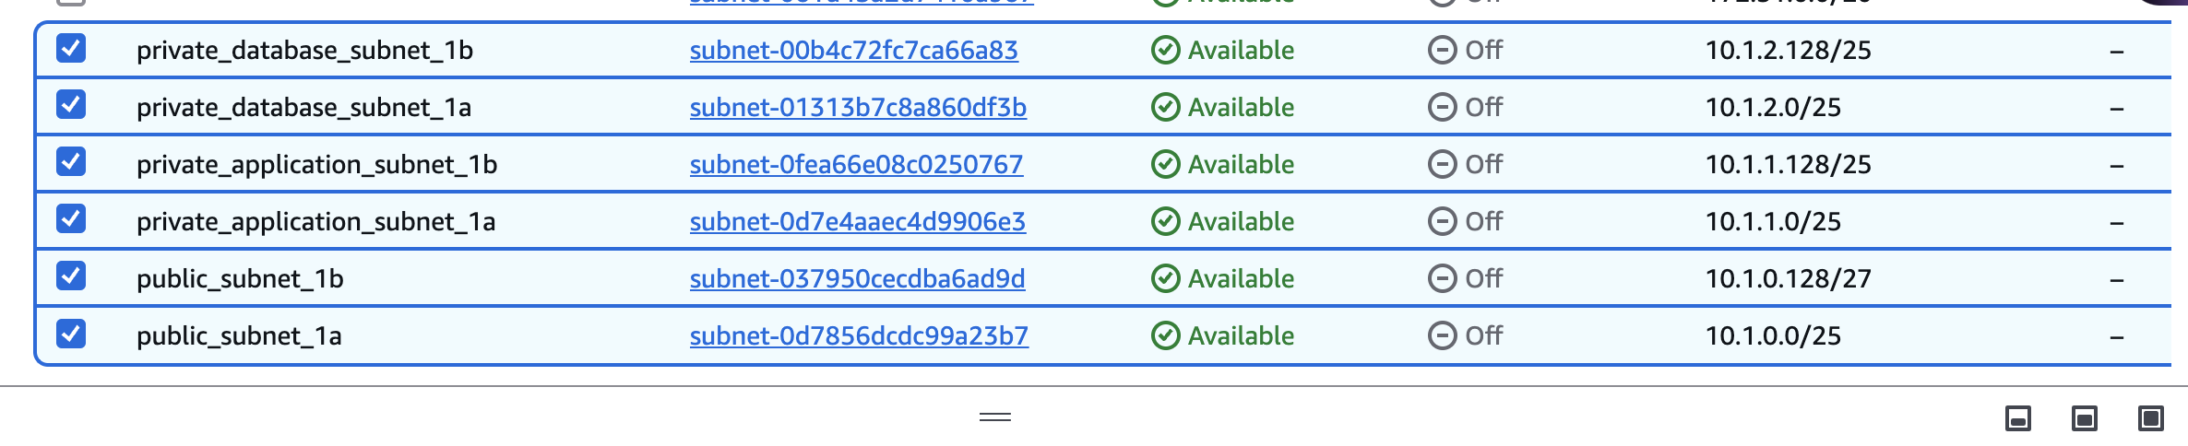

**Internet and NAT Gateways**

Create an Internet Gateway (IGW) and attach it to the VPC.

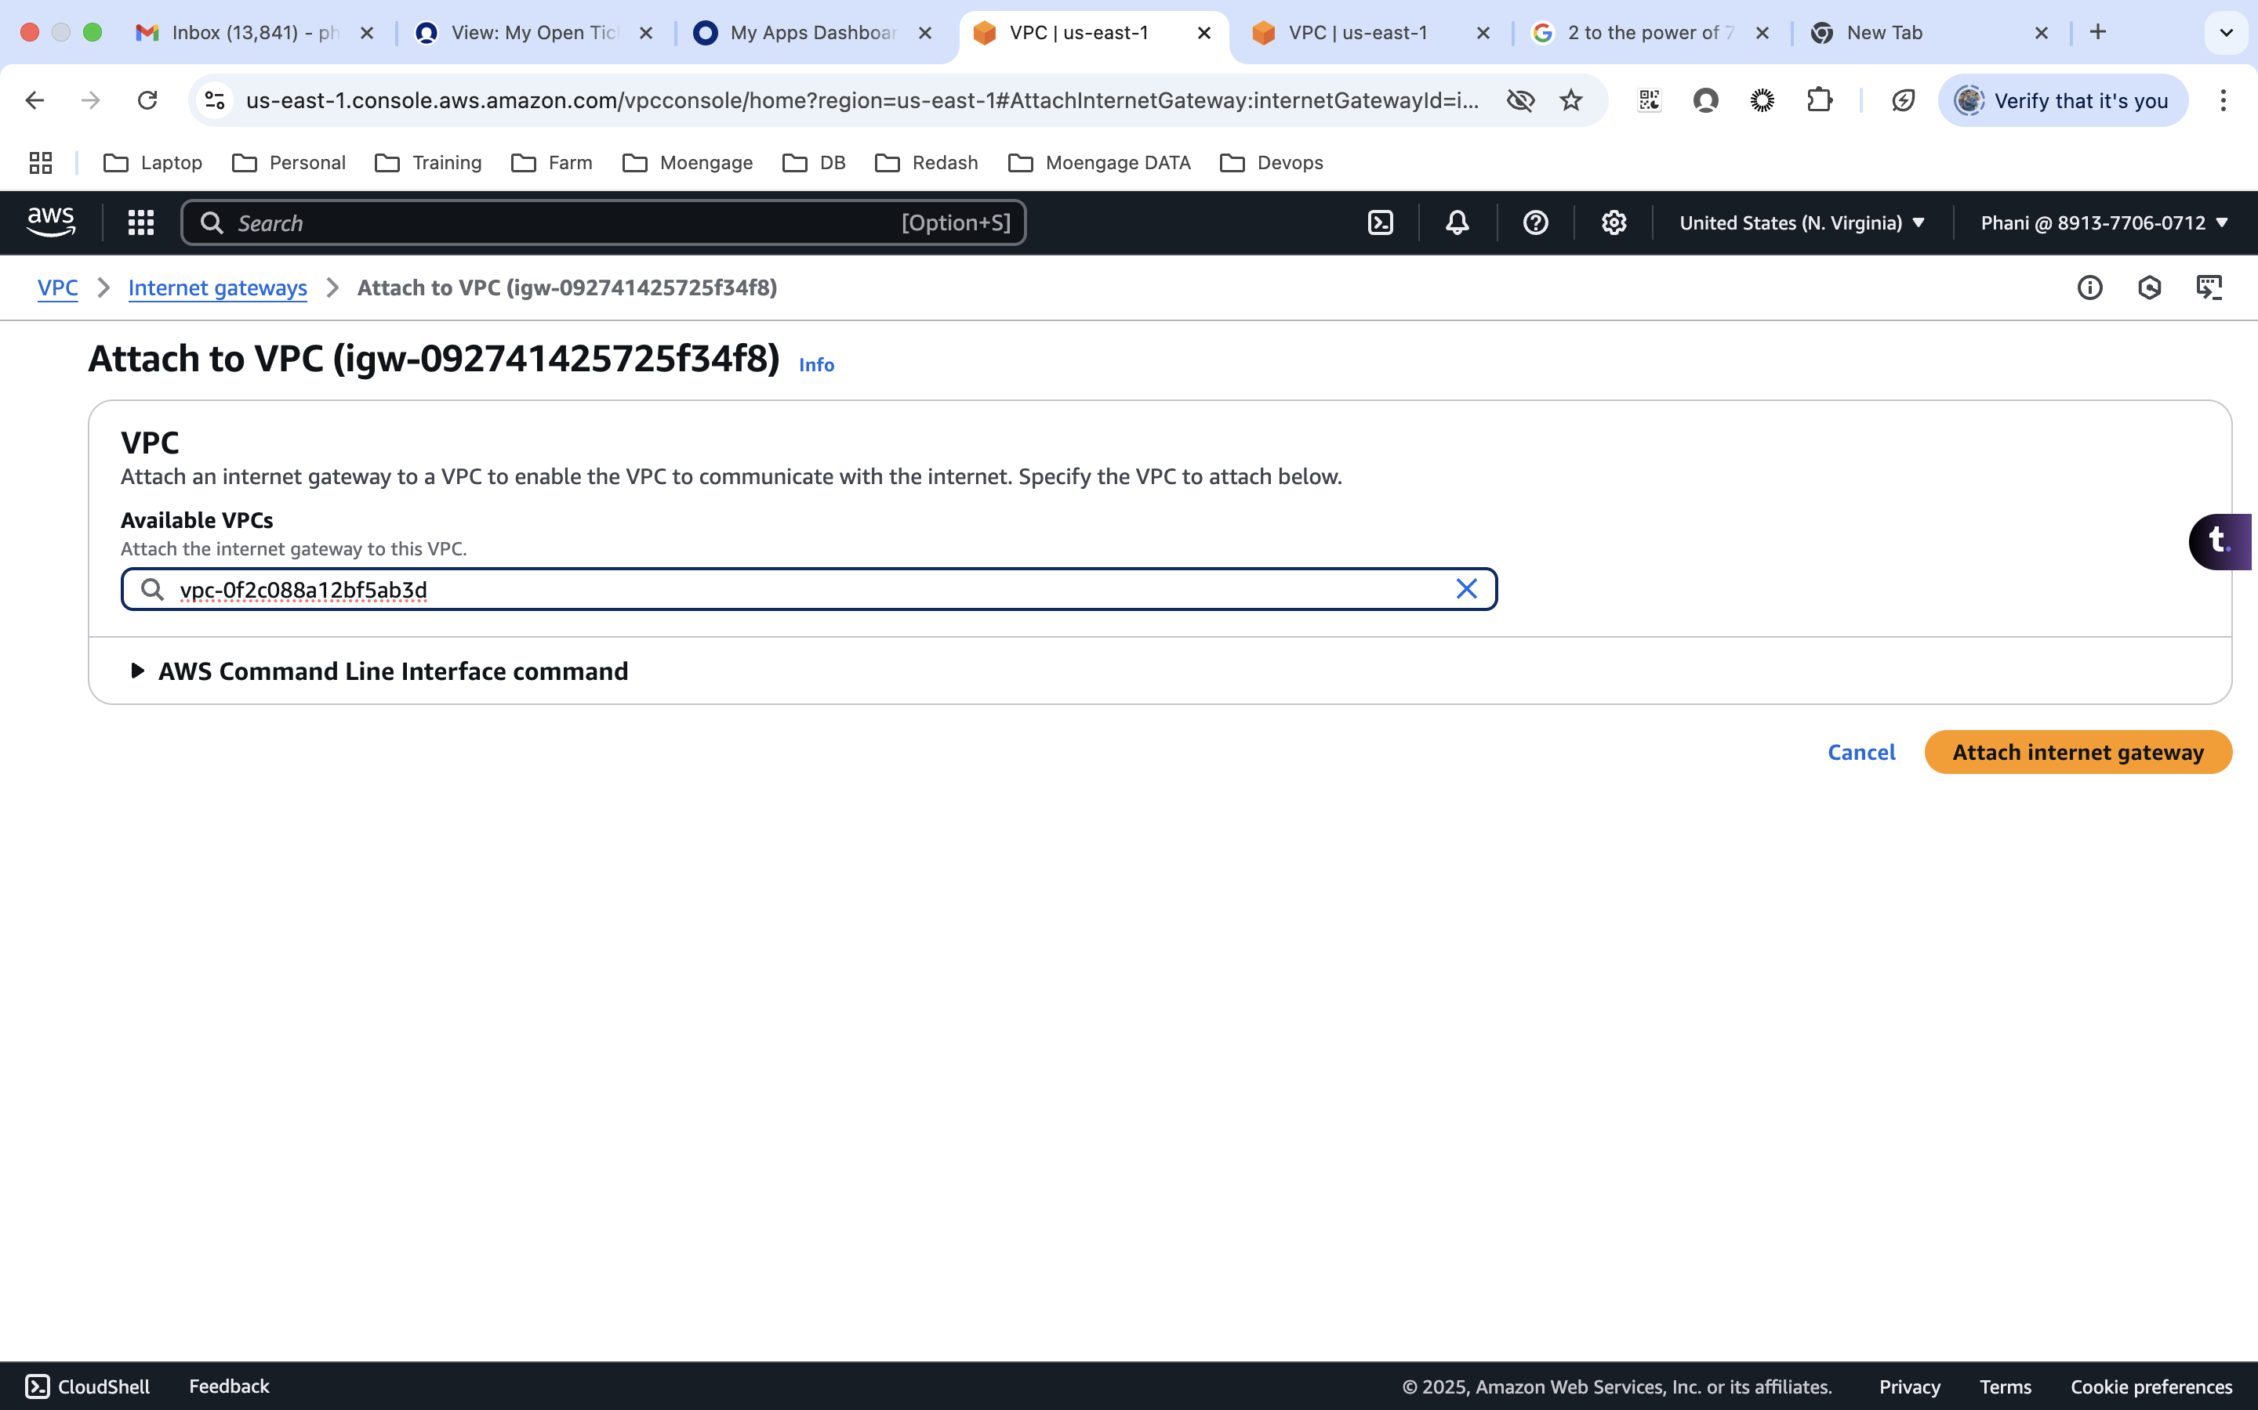

**Deploy a NAT Gateway in one of the public subnets.**

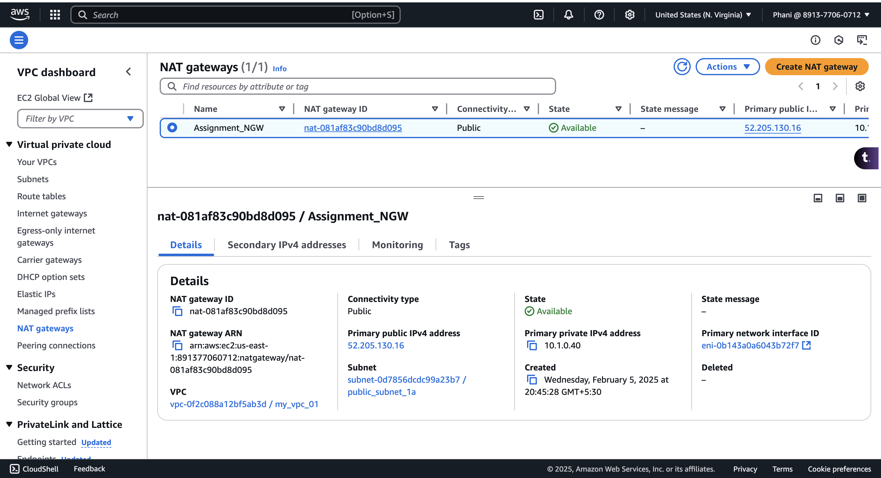

**Route Tables and Routing**

Create a Public Route Table and associate it with public subnets.

Routes:

0.0.0.0/0 → Internet Gateway

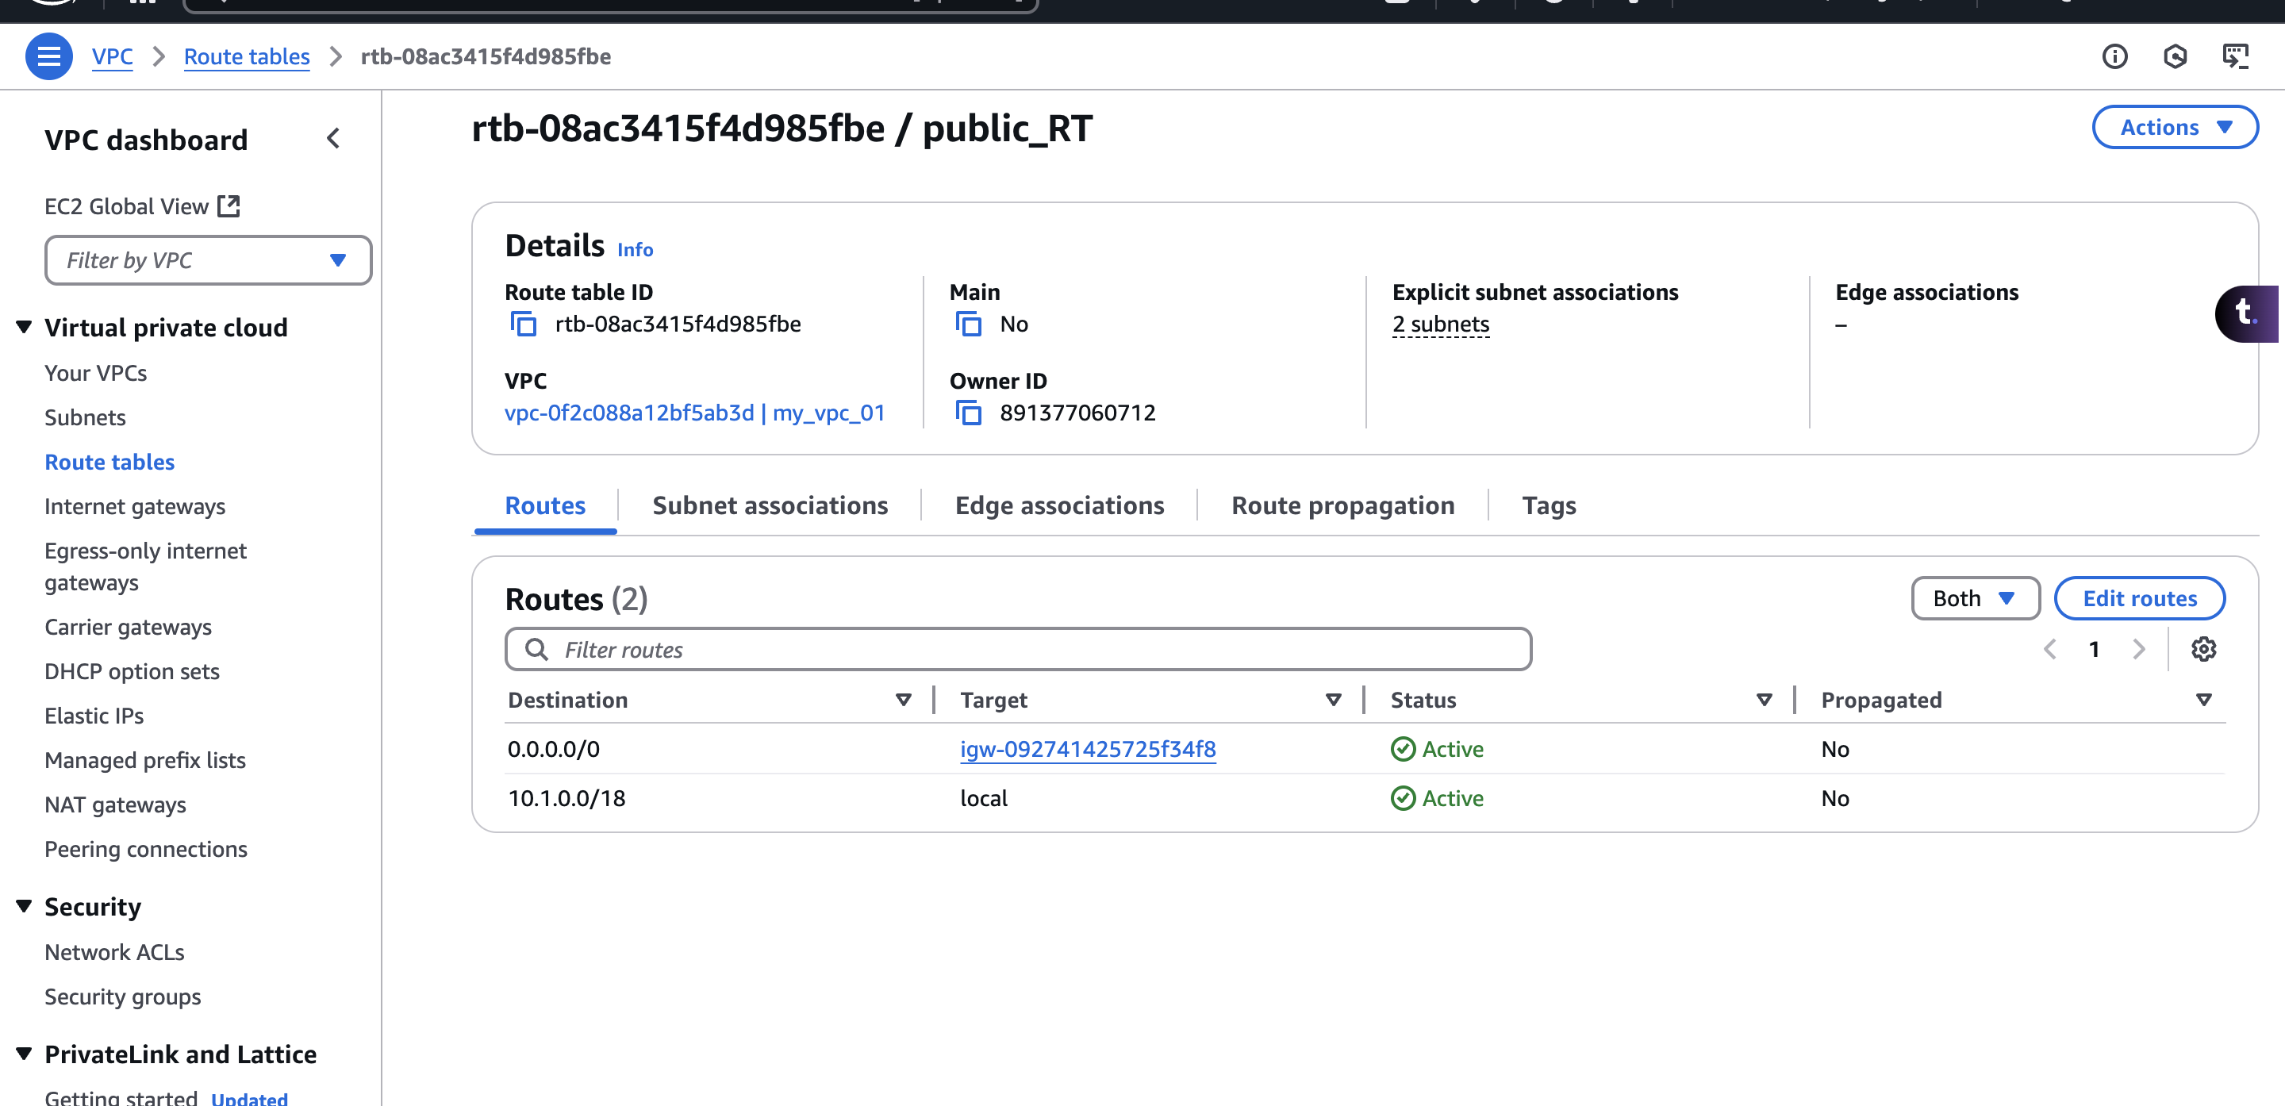

Create a Private Route Table and associate it with private subnets.

Routes:

0.0.0.0/0 → NAT Gateway (for outbound internet access from private subnets).

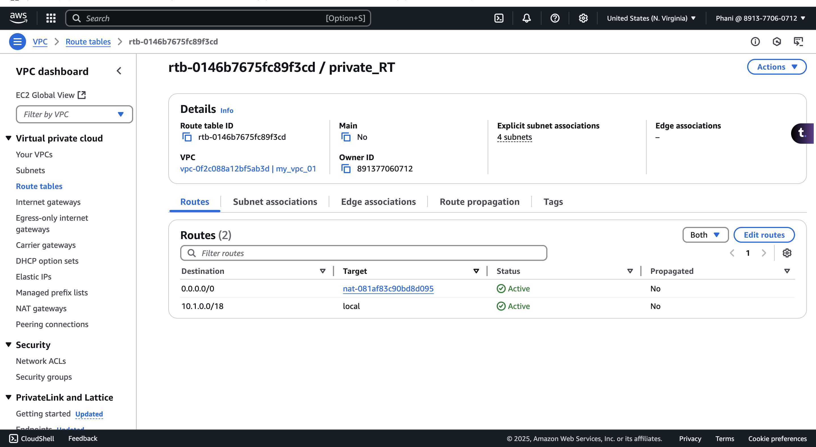

**Security Groups & NACLs**

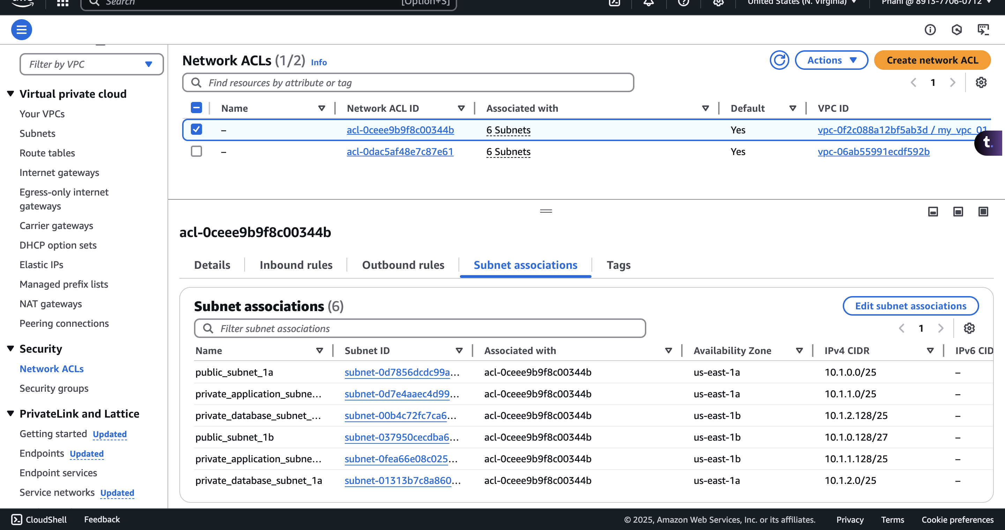

Public Subnet Security Group: Allow inbound SSH (22) and HTTP (80) from the internet.

Create Public Subnet Security Group

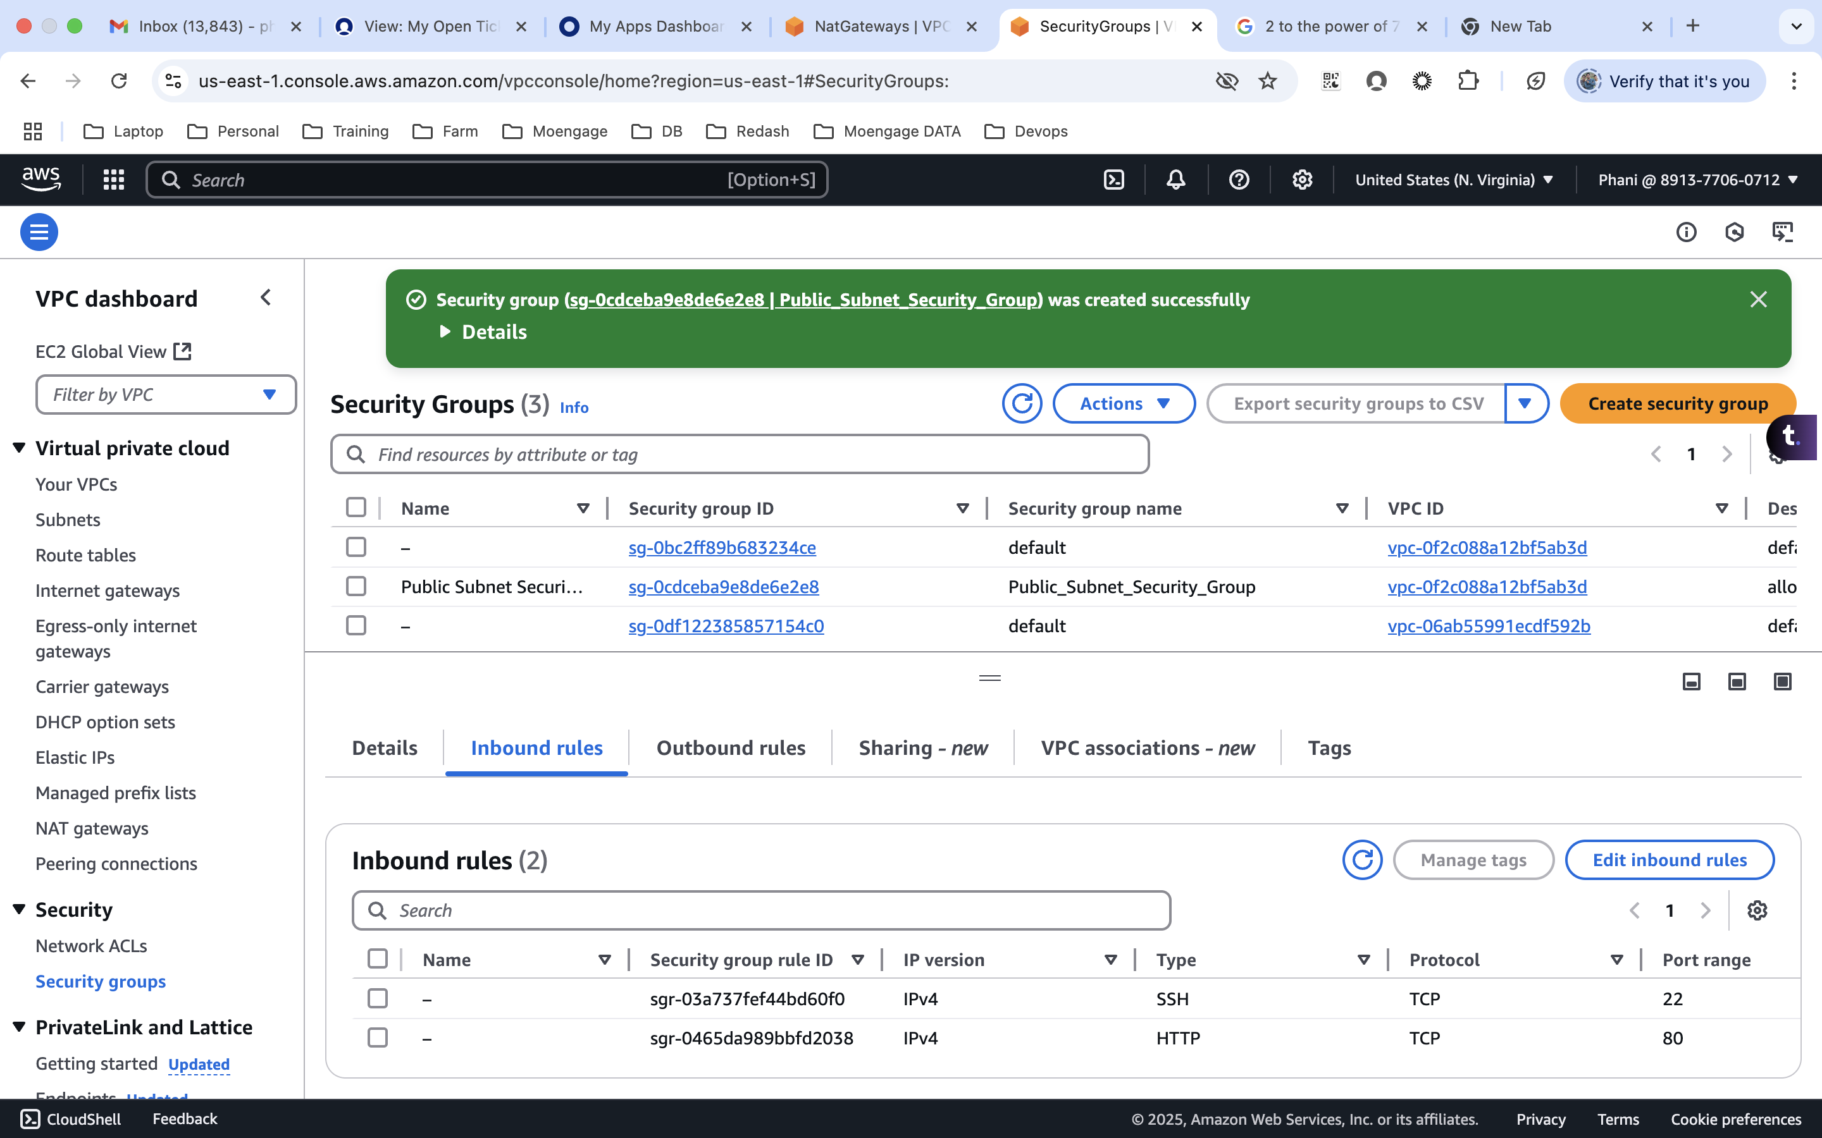

Private Application Subnet Security Group: Allow inbound traffic only from the Public Subnet.

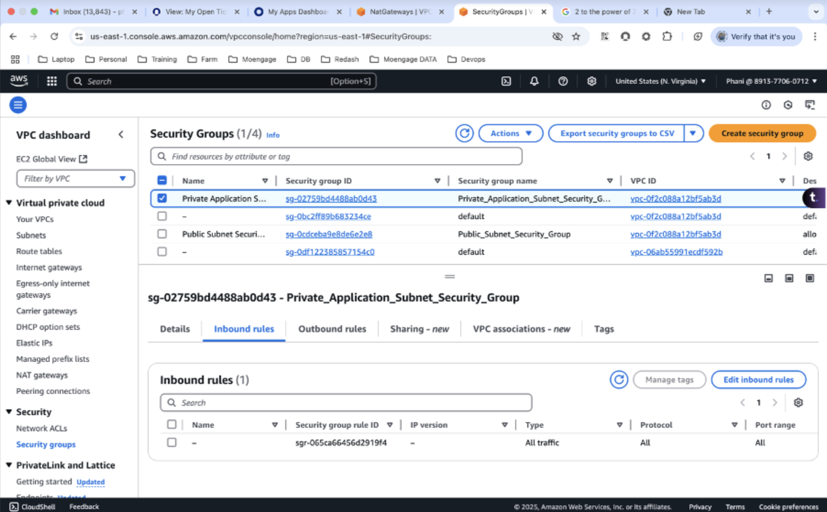

Private Database Subnet Security Group: Allow inbound traffic only from the Private Application Subnet.

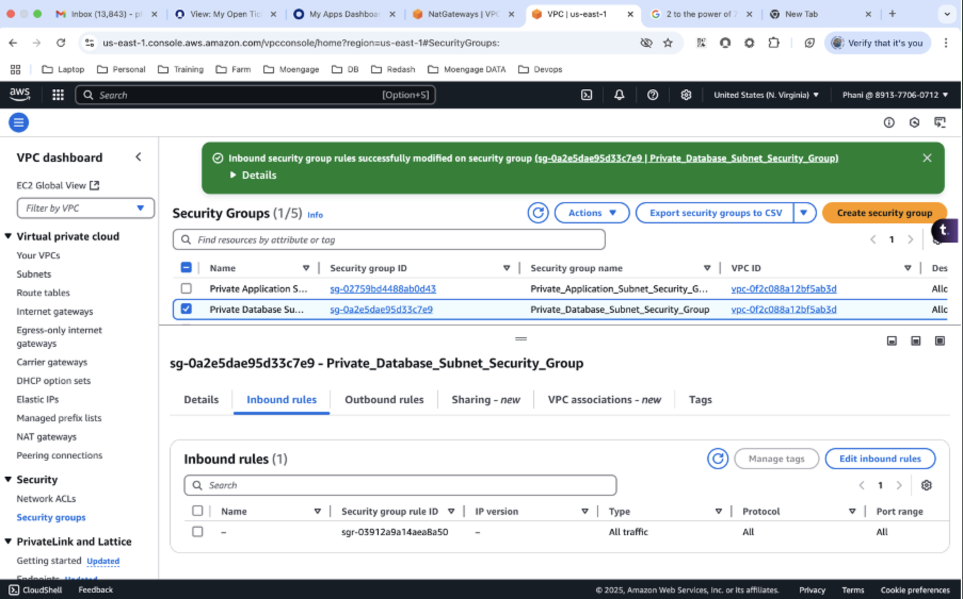

Note: Delete the resource to avoid billing

1. Remove the NAT gateway mapping in Private route table
2. Delete the NAT gateway
3. Under the Elastic Ips, release the elastic ip
4. delete the security groups, , internet gateway, subnets, routing tables, VPC